**Machine Translation Lab Task**

**20K-0477**

**Mohammad Basil Ali Khan**

**Test Sample Output:**

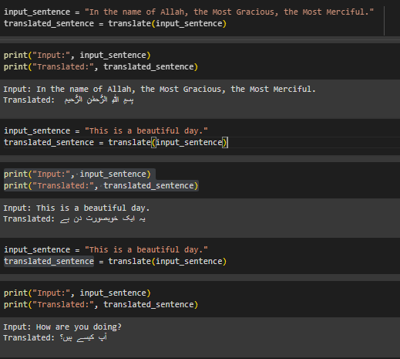

**Bleu Score:**

